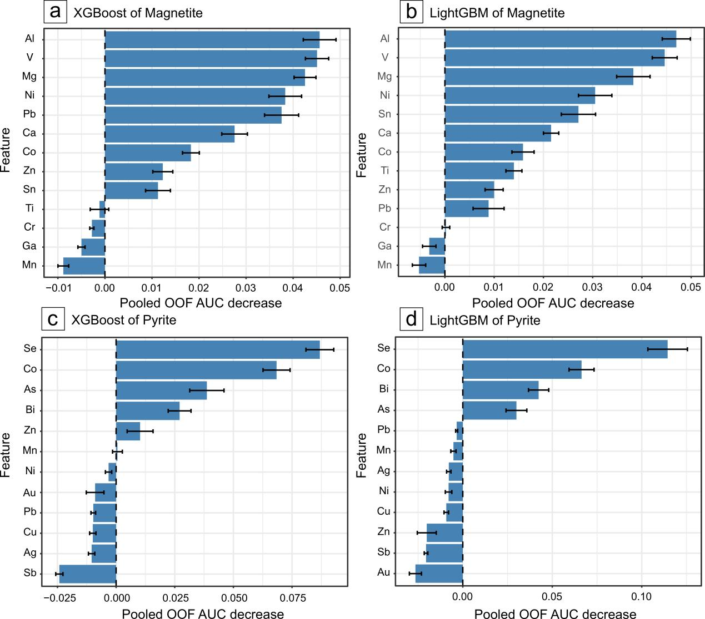
Supplementary Figure 1. Permutation importance of trace elements in the magnetite-based (a, b) and pyrite-based (c, d) XGBoost and LightGBM models. Bars show the mean decrease in pooled out-of-fold (OOF) AUC after randomly shuffling each element’s values 20 times without retraining the models. Error bars represent ±1 standard deviation. Larger positive values indicate greater predictive importance, whereas negative values indicate improved AUC after permutation. Dashed vertical lines mark zero change in AUC.

